

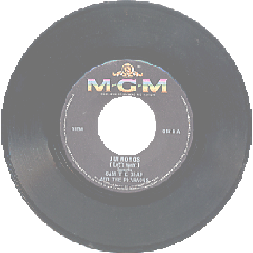


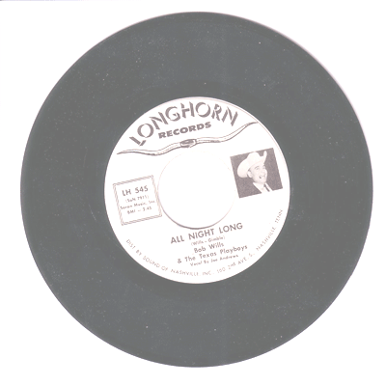

Lovers’ Rock
Where:
Presbyterian Church
5400 S Yosemite St
Greenwood Village, CO
(Bring Your Own Lunch
meeting place)

When:
Saturday,
February 10, 2007

Service Expo 5-7pm
Speaker 7pm
Dance 8:30 – midnight

Service Expo: FREE
Dance: $10

Live music and show: Musa Konate

Musa Konate and The Lost Tribe thrill their audience with electrifying performances, musing them with an eclectic mix of musical styles ranging from African—Soukouss, Makossa, and Mbalax to Caribbean—Reggae, Zouk, Calypso, and Compa; with a touch of American—R&B, Jazz, and Rock.

Service Expo 2007
Fund Raiser to produce
Unity Day Speakers Jam
@ Mile High Area
Phone-line • H&I • Training • Outreach • PI • Activities
Presentation, learning & sign-up for service
refreshments provided
Service Expo is free

featuring

